

**North South University**

**Department of Electrical & Computer Engineering**

**Assignment-2 ( Resubmission )**

|  |  |
| --- | --- |
| **Course Code:** | **CSE 440.1** |
| **Course Name:** | Artificial Intelligence |

|  |  |
| --- | --- |
| **Prepared By:** | **Ridowan Ahmed** |
| **Email:** | [navid.rashik@gmail.com](mailto:navid.rashik@gmail.com) |
| **Facebook:** | <https://www.facebook.com/navid.rashik> |

|  |  |
| --- | --- |
| **Student ID:** | **Student Name:** |
| **1410951042** | Navid Anjum Chowdhury |

**Mit Problems**

**Problem 3**

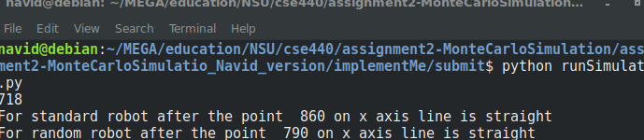After the simulation we find that standard robot takes 718 timesteps to complete 10*10 room.

**Problem 4a**

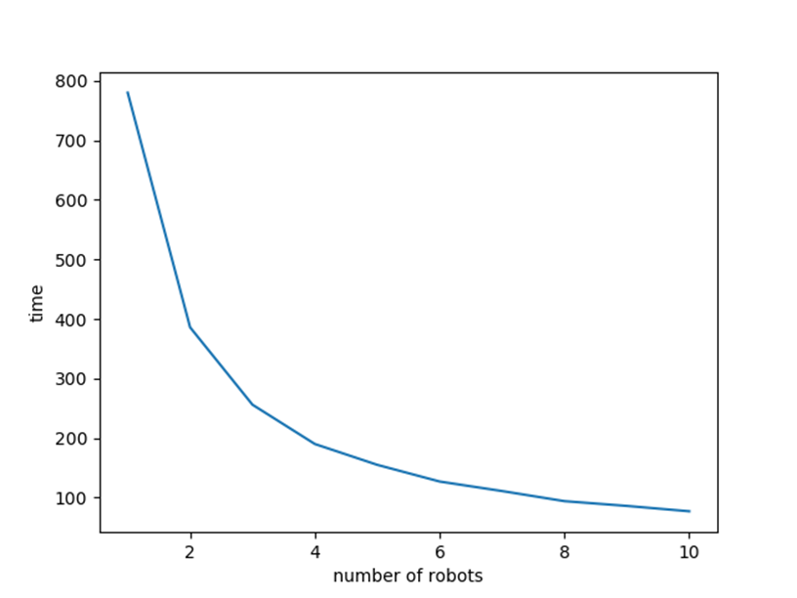

In the above graph we can see that the standard robot takes how much time to complete cleaning a 20*20 room with 80% target when the number of those robot increases.

**Problem 4b**

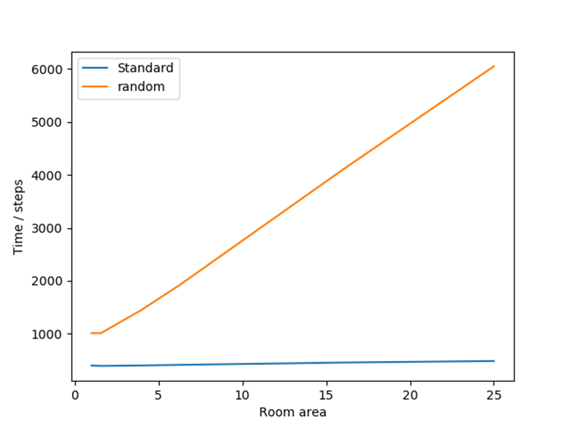

This program gives the above graph where we can compare how much time is needed for a single random and standard robot when the room size is increased.

**Problem #6**

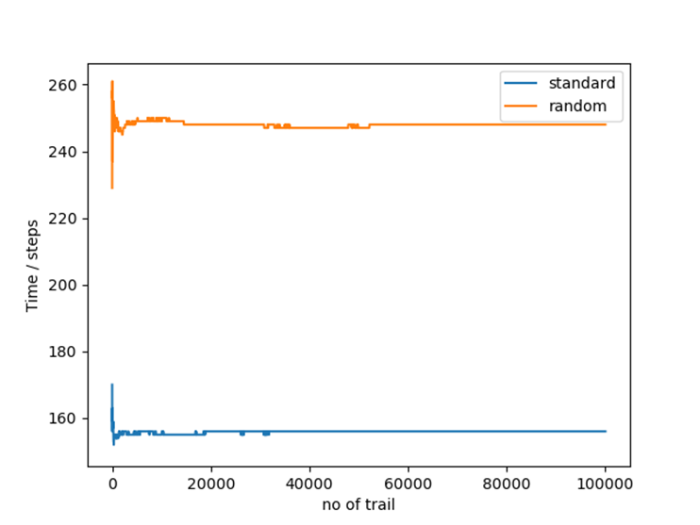

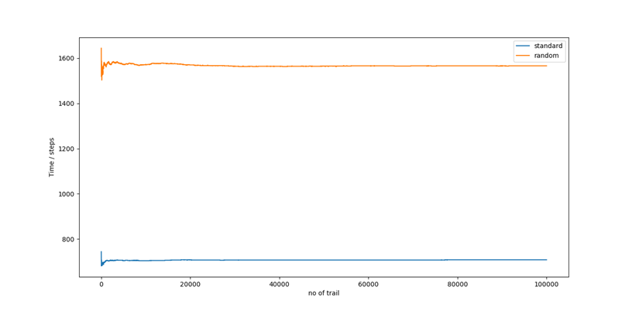This program returns graph with target percentage cleaning with the number or time it will take average to make the graph linear.

**Given Problem (2,3,4)**

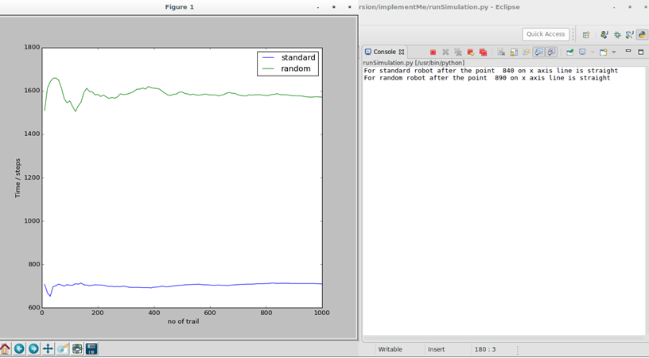

Both of this graph become almost linear after 800 trial average. Tolerance of the graph is 0.5%. Both of these graphs become more stable after 500 trial average . From this graph random Robot takes almost 900 more steps to clean the room.

To clean a 10 x 10 room standard robot takes almost 700 time steps where a random robot takes nearly 1600 time steps. After so many trails when the line become linear then it means it is more likely the outcome will be like this or in this case those robot will take the estimated amount of time.   
  
  
I the beginning of the graph for random robot the graph bounce higher than the standard robot. This happens because random robot goes random direction every time but standerd robot goes random direction only after getting hit by wall and this restrict standard robot to clean the same place again and again. This way random robot take too many steps but a standerd robot takes far less .